Packet Tracer - Interpret show Command Output

# Objectives

Part 1: Analyze Show Command Output

Part 2: Reflection Questions

# Background

This activity is designed to reinforce the use of router **show** commands. You are not required to configure, but rather to examine the output of several **show** commands. This activity does not automatically provide a score.Instructions

## Analyze Show Command Output

* + - 1. To connect to ISPRouter, Click **ISP PC**, then the **Desktop** tab, followed by **Terminal**.

Open configuration window

* + - 1. Enter privileged EXEC mode.
      2. Use the following **show** commands to answer the Reflection Questions in Part 2.

**Note**: If a command pauses with the -–More—prompt, make certain to hit the spacebar until the **ISPRouter#** prompt appears in order to obtain all of the command output.

show arp



show flash:

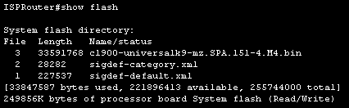

show ip route

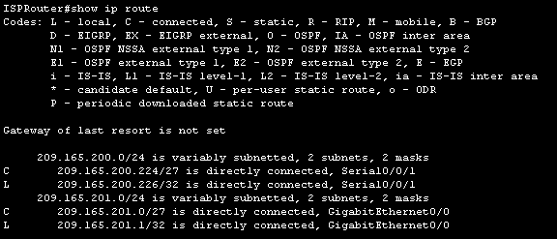

show interfaces

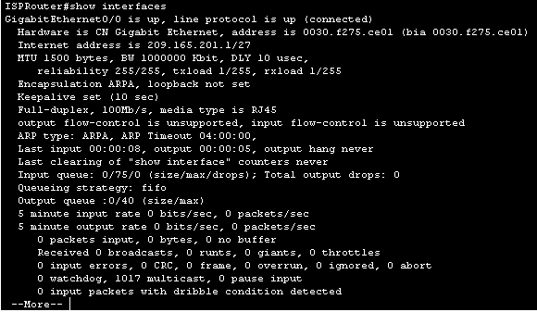

show ip interface brief

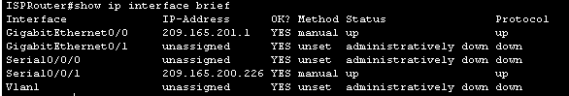

show protocols

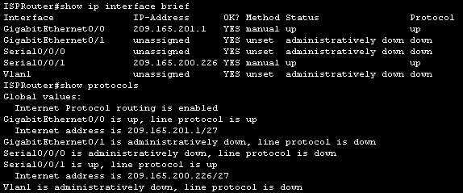

show users

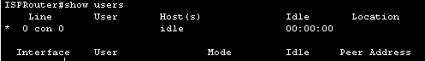

show version

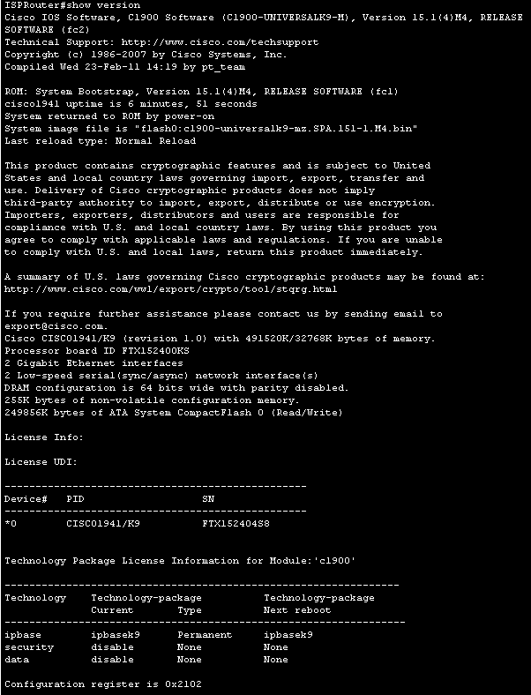

Close configuration window

## Reflection Questions

* 1. Which commands can you use to determine the IP address and network prefix of interfaces?

show ip route, show interfaces, show protocols

Type your answers here.

* 1. Which command provides the IP address and interface assignment, but not the network prefix?

show ip interface brief

Type your answers here.

* 1. Which commands would you use to determine if an interface is up?

show interfaces, show ip interface brief, show protocols

Type your answers here.

* 1. You need to determine the IOS version that is running on a router. Which command will give you this information?

show version

Type your answers here.

* 1. Which commands provide information about the addresses of the router interfaces?

show arp, show interfaces, show ip route, show ip interface brief, show protocols

Type your answers here.

* 1. You are considering an IOS upgrade and need to determine if router flash can hold the new IOS. Which commands provide information about the amount of Flash memory available?

show version, show flash

Type your answers here.

* 1. You need to adjust a router configuration, but you suspect that a colleague may also be working on the router from another location. Which command provides information about the lines being used for configuration or device monitoring?

show users

Type your answers here.

* 1. You have been asked to check the performance of a device interface. Which command provides traffic statistics for router interfaces?

show interfaces

Type your answers here.

* 1. Customers are complaining that they cannot reach a server that they use for file storage. You suspect that the network may have become unreachable due to a recent upgrade. Which command provides information about the paths that are available for network traffic?

show ip route

Type your answers here.

* 1. Which interfaces are currently active on the ISP Router?

GigabitEthernet 0/0, Serial 0/0/1

Type your answers here.

End of document